

**JSC “Kazakh British Technical University”**

**Faculty of Information Technology**

**Microprocessor Control Systems**

**Laboratory Work #2**

**Prepared by: Maratuly Temirbolat**

**Almaty 2021**

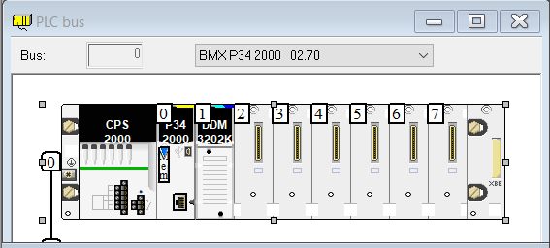

**Task 2.2**

It is necessary to improve task 2.1 so that when the button is pressed, the bit value lights up, and the value of the example_byte variable is displayed in the text field. An example of visualization in the operator screen is shown in Figure 2.2.

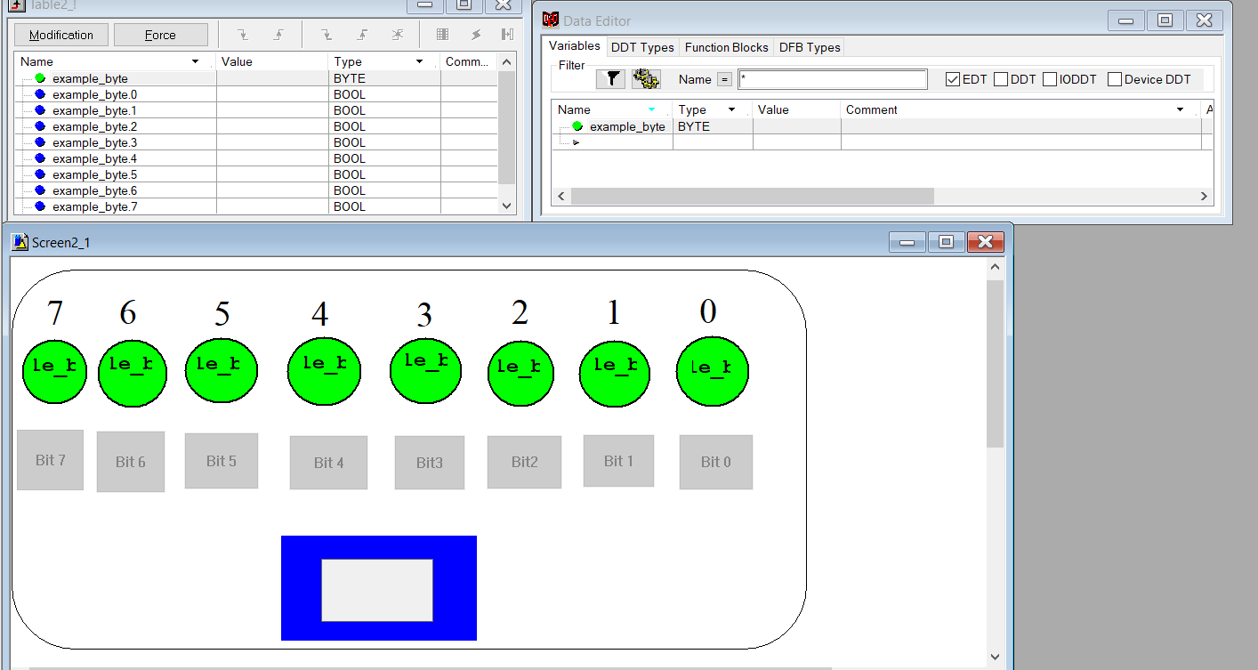

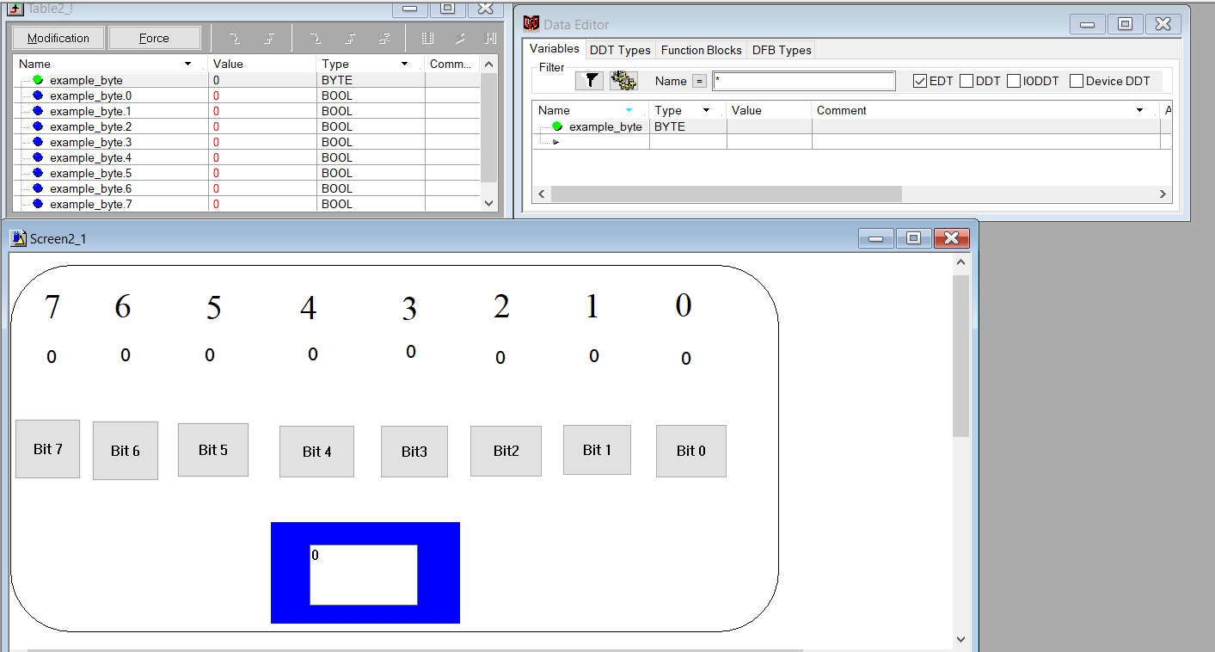

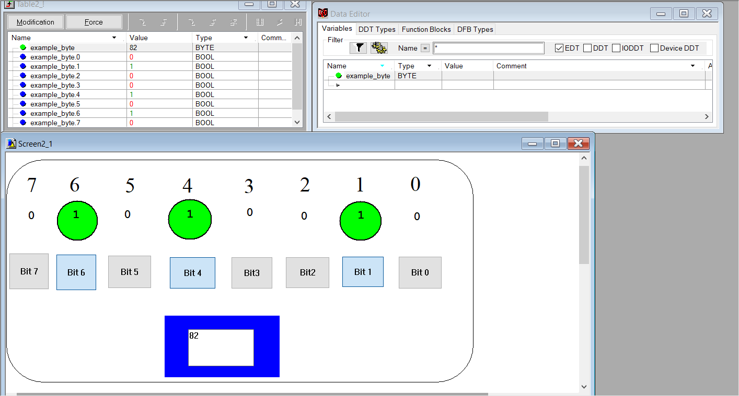

**Task 2.3**

You need to check the data types of the EDT (Elementary Data Type) section in the Unity Pro environment. To do this, you need to create the variables presented in table 2.2.

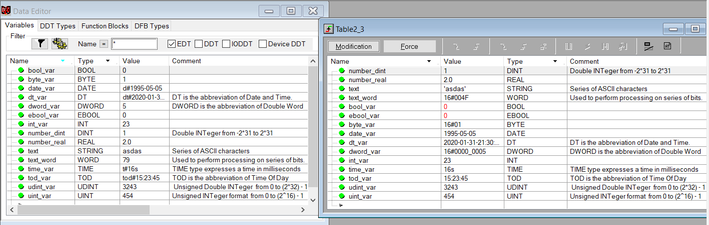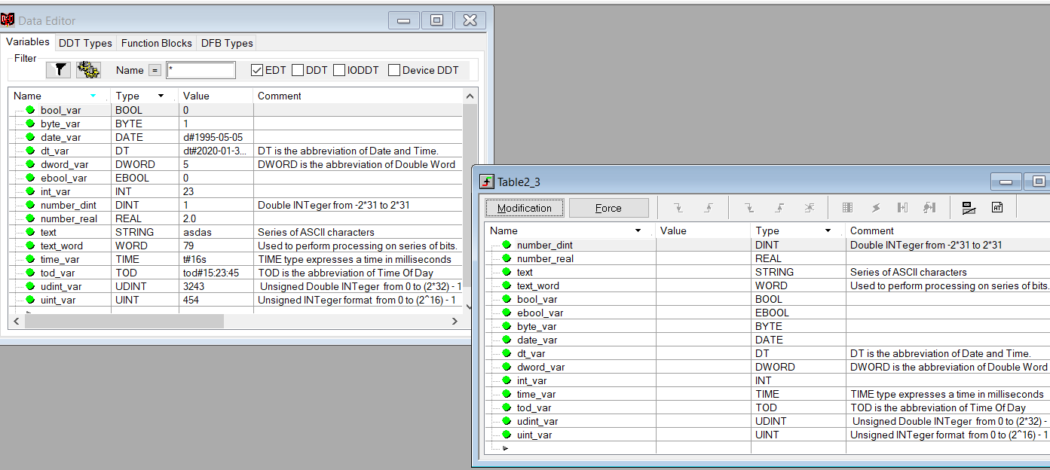

**Control questions:**

1. What is the classification of UNITY PRO software data types?
2. What is the role of Elementary Data Type variables?
3. Name the data types of the EDT category.
4. Describe the BYTE data format.
5. Describe the data format DINT, REAL, STRING and WORD
6. What is the function of the animation table in Unity Pro?

**Answers:**

1. Unity Pro has the following data type classification: **1.**EDT (Elementary Data Type) is an elementary data type containing 15 types (BOOL, EBOOL, REAL, INT, DINT, TIME, BYTE, WORD, DWORD, etc.). **2.** DDT (Derived Data Type) - custom data type, given by the developer. **3.** IODDT (Input Output Derived Data Types) is a user-defined data type that contains commands, variables, information about errors.
2. scale - the number of bits that the variable occupies in memory; memory recording format; prefix is a visual representation of a variable in Unity Pro. There are two types of variables: - localized with addresses; - non-localized without addressing
3. BOOL, EBOOL, REAL, INT, DINT, TIME, BYTE, WORD, DWORD, STRING,DATE, DT, TOD, UDINT, UINT
4. When 8 bits are grouped together, they are called a BYTE. You can enter a BYTE either in binary mode or in base 8. The BYTE type is encoded in an 8 bit format which, in hexadecimal format, ranges from 16#00 to 16#FF.
5. DINT is the abbreviation of Double INTeger (encoded in 32 bits).

The upper/lower limits are as follows: -(2 to the power of 31) to (2 to the power of 31) - 1.

A STRING variable is a series of ASCII characters. The maximum length of a string is 65,534 characters.

The type WORD is encoded in a 16 bit format and is used to perform processing on series of bits.

|  |  |  |
| --- | --- | --- |
| **Base** | **Lower limit** | **Upper Limit** |
| Hexadecimal | 16#0 | 16#FFFF |
| Octal | 8#0 | 8#177777 |
| Binary | 2#0 | 2#1111111111111111 |

1. The Animation is the Unity Pro’ basic tool for viewing and forcing the status of variables. Also, we can change the scale of the variables, its properties and change BOOL and EBOOL variables from 0 to 1 and wise versa.

**Conclusion:**

During the laboratory work we used the PLC BMX P34 2000 and tried to work with EDT data type that contains 15 types which we experienced. Also, we were turning on and switching off the bits of a single byte (from 0 to 1 and wise versa) in order to change its value from 0 to 255 that are the lowest and highest figures. While the work there were introduced such shapes as rectangle, ellipse, entry field, text as well as push button. There were introduced such variables which have TIME, DINT, REAL, STRING, WORD, BOOL, BYTE, DATE and so on data types for which we used the different views in order to work with it and sow the new data type as EBOOL that has about the same properties.